**GANPAT UNIVERSITY**

**U.V.PATEL COLLEGE OF ENGINEERING & TECHNOLOGY**

**Department of Computer Science and Engineering**

**B.Tech 1ST Semester   Subject – ESFP-1**

**First Name:   Manan bhatt    Enrollment Number:  t14012121006          Stream : BDA**

**Assignment -1                                                                           Date:27/8/14**

Goal: to learn about backslash characters, c tokens ,data types in brief.

Answer 1

CODE TO PRINT ASCII VALUE OF BACKSLASH CHARACTER

#include<stdio.h>

#include<conio.h>

void main()

{

char a;

clrscr();

a='\a';

printf("\nthe ascii value ofaudible bell is:%d",a);

a='\b';

printf("\nthe ascii value of backspace is:%d",a);

a='\f';

printf("\nthe ascii value of form feed is:%d",a);

a='\n';

printf("\nthe ascii value of new line is:%d",a);

a='\r';

printf("\nthe ascii value of carriage return is:%d",a);

a='\t';

printf("\nthe ascii value of horizontal tab is:%d",a);

a='\v';

printf("\nthe ascii value of vertical tab is:%d",a);

a='\?';

printf("\nthe ascii value of question mark is:%d",a);

a='\\';

printf("\nthe ascii value of backslash is:%d",a);

a='\"';

printf("\n the ascii value double quote is %d",a);

a='\'';

printf("\n the ascii value of single quote is %d",a);

getch();

}

OUTPUT

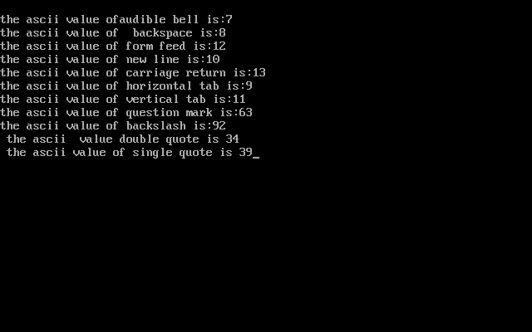

2. Explain different data types available in C.

Answer 2:-

C language is a language i.e. rich in data type. Storage representation and instructions to handle varies from machine to machine. This variety of data type allows the user to use appropriate data type according to his use.

C supports three data types namely:-

1. Primary data type
2. Derived data type
3. User- defined data type

PRIMARY DATA TYPES:- Majorly all the c compilers have five fundamental data types namely integer(int), floating point(float), double precession floating point(double), character (char) and void. Various data types and terminology are used to describe them.

DERIVED DATA TYPES: - the derived data types include data types such as arrays, functions, structures and, pointers.

USER DEFINED DATA TYPES:- C supports a feature known as type definition which allows the user to crate a new identifier that would represent an existing data type in rest of the program.

1. Explain about C Tokens in brief.

Answer 3:- Like in a passage words and the punctuations are known as tokens,similarly in c the smallest individual units are known as tokens . C has mainly six tokens

1. Keyword
2. Identifiers
3. Constants
4. Strings
5. Special symbols
6. Operators

The all c tokens are combined and used in a program as per the requirement of the definition of program to give an proper output.

1. Explain about backslash characters in C.

Answer 4 :- C language supports SPECIAL backslash characters that are used in the output.

The various backslash characters are

|  |  |
| --- | --- |
| CONSTANTS | MEANING |
| ‘\a’ | Audible alert |
| ‘\b’ | Backspace |
| ‘\f’ | Form feed |
| ‘\n’ | New line |
| ‘\r’ | Carriage return |
| ‘\t’ | Horizontal tab |
| ‘\v’ | Vertical tab |
| ‘\”’ | Double quote |
| ‘\” | Single quote |
| ‘\\’ | Backslash |
| ‘\?’ | Question mark |